 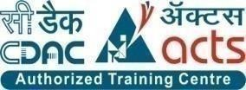

**INSTITUTE FOR ADVANCED COMPUTING ANDSOFTWARE DEVELOPMENT (IACSD), AKURDI, PUNE**

Documentation On

CLASSHUB-ONLINE MANAGEMENT SYSTEM

PG-DAC March 2023

# Submitted By:

**Group No: 113**

**Roll No. Name:**

**233216 siddharth sharma**

**233199 saikat das**

# Mr. NARENDRA PAWAR Mr. Rohit Puranik

**Project Guide Centre Coordinator**

# ABSTRACT

Student Management System is software which is helpful for students as well as the school authorities. In the current system all the activities are done manually. It is very time consuming and costly. Our Student Management System deals with the various activities related to the students. In the Software we can register as a user and user has of two types, student and administrator. Administrator has the power to add new user and can edit and delete a user. A student can register as user and can add edit and delete his profile. The administrator can add edit and delete marks for the student. All the users can see the marks.

# 

# ACKNOWLEDGEMENT

I take this occasion to thank God, almighty for blessing us with his grace and taking our endeavor to a successful culmination. I extend my sincere and heartfelt thanks to our esteemed guide, **Mr. NARENDRA PAWAR** for providing me with the right guidance and advice at the crucial juncture sand for showing me the right way. I extend my sincere thanks to our respected **Centre Co-Ordinator Mr. Rohit Puranik**, for allowing us to use the facilities available. I would like to thank the other faculty members also, at this occasion. Last but not the least, I would like to thank my friends and family for the support and encouragement they have given me during the course of our work.

#### Siddharth sharma (233216)

**Saikat das (233199)**

# Table of Contents

ABSTRACT 1

ACKNOWLEDGEMENT 2

INTRODUCTION 6

FEATURES 6

* 1. PROJECT OBJECTIVE 7
  2. PROJECT OVERVIEW 7
  3. PROJECT SCOPE 8
  4. STUDY OF THE SYSTEM 8
     1. MODULES 8

SYSTEM ANALYSIS 16

* 1. EXISTING SYSTEM 16
  2. PROPOSED SYSTEM 16
  3. SYSTEM REQUIREMENT SPECIFICATION 16
     1. GENERAL DESCRIPTION 16
     2. SYSTEM OBJECTIVES 17
     3. SYSTEM REQUIREMENTS 17

SYSTEM DESIGN 19

* 1. INPUT AND OUTPUT DESIGN 19
     1. INPUT DESIGN 19
     2. OUTPUT DESIGN 19

DATABASE DESIGN 21

* 1. DATABASE 21
  2. SYSTEM TOOLS 21
     1. FRONT END 21
     2. BACKEND 21

E-R DIAGRAM 26

CLASS DIAGRAM 27

TABLE STRUCTURE 28

PROJECT DIAGRAMS 29

CONCLUSION 50

REFERENCES 51

**LIST OF FIGURES**

#### FIGURE 1: STUDENT ACTIVITY DIAGRAM 11

**FIGURE 7: E-R DIAGRAM 27**

#### FIGURE 8: CLASS DIAGRAM 28

**FIGURE 9: TABLE STRUCTURE 29**

**FIGURE 10: PROJECT DIAGRAMS 32**

# INTRODUCTION

Our Project “CLASSHUB” aims to deliver a web-based portal that manages all the students admitted in the any institution where Course- Coordinator is the Admin.

Students can update their profile, get schedule, join lectures and their respective labs, write module-wise, get the results and also give their feedback for each faculty.

Admins can generate PRN for registered students, upload exam papers, set results, get feedback list, etc. They also can upload links for lectures and labs as well as set notice.

## PROJECT OBJECTIVE

Our project, “CLASSHUB”, is a web-based online student management portal which aims to provide admin with functionalities to manage students in any particular institute efficiently.

## PROJECT OVERVIEW

“CLASSHUB” aims to deliver a web-based portal that manages all the students admitted in institute where Course- Coordinator is the Admin. Students can update their profile, get schedule, join lectures and their respective labs, write module-wise MCQ tests, get the results and also give their feedback for each faculty. Admins can generate PRN for registered students, upload exam papers, set results, get feedback list, etc. They also can upload links for lectures and labs as well as set notice.

We are assuming that the organization that implements it will be using third-party platform where lectures are conducted. Also, an API which can easily be integrated in our application can be created in future if needed. CLASSHUB is a portal for both students (for course related activities) and admins (for managing students).

## PROJECT SCOPE

“CLASSHUB” aims to deliver a web-based portal that manages all the students admitted in institute where Course- Coordinator is the Admin. Students can update their profile, get schedule, join lectures and their respective labs, write module-wise MCQ tests, get the results and also give their feedback for each faculty. Admins can generate PRN for registered students, upload exam papers, set results, get feedback list, etc. They also can upload links for lectures and labs as well as set notice.

We are assuming that the organization that implements it will be using third-party platform where lectures are conducted. Also, an API which can easily be integrated in our application can be created in future if needed. CLASSHUB is a portal for both students (for course related activities) and admins (for managing students).

## STUDY OF THE SYSTEM

## MODULES:

The Web-Application after careful analysis has been identified to be presented with the following modules and roles.

The modules involved are:

* + - * Student
      * Admin
      * Faculty
      1. Students:

i. FOR STUDENTS

a. Register – Students can register themselves if they have appeared for CCAT entrance exam for PG Diploma courses and have valid CCAT number.

b. Login – Successfully registered candidates receive confirmation Email from IACSD and are now eligible to Login. They receive PRN to Login into the portal. For first time login, username and default password both are PRN.

c. View and Update Profile – After successful login, students can view and update their profile and password.

d. Join Link – Students can join lectures and labs using the links provided under the Join Link dropdown in navigation bar.

e. Exam – Students can give module-wise MCQ exam on the portal itself.

f. Result – Students get the result of MCQ test module-wise.

g. Give Feedback – Students can give feedback for faculties based on provided criteria.

h. Logout – After utilizing the portal, students can Logout of the portal..

### Figure 1 Student Activity Diagram

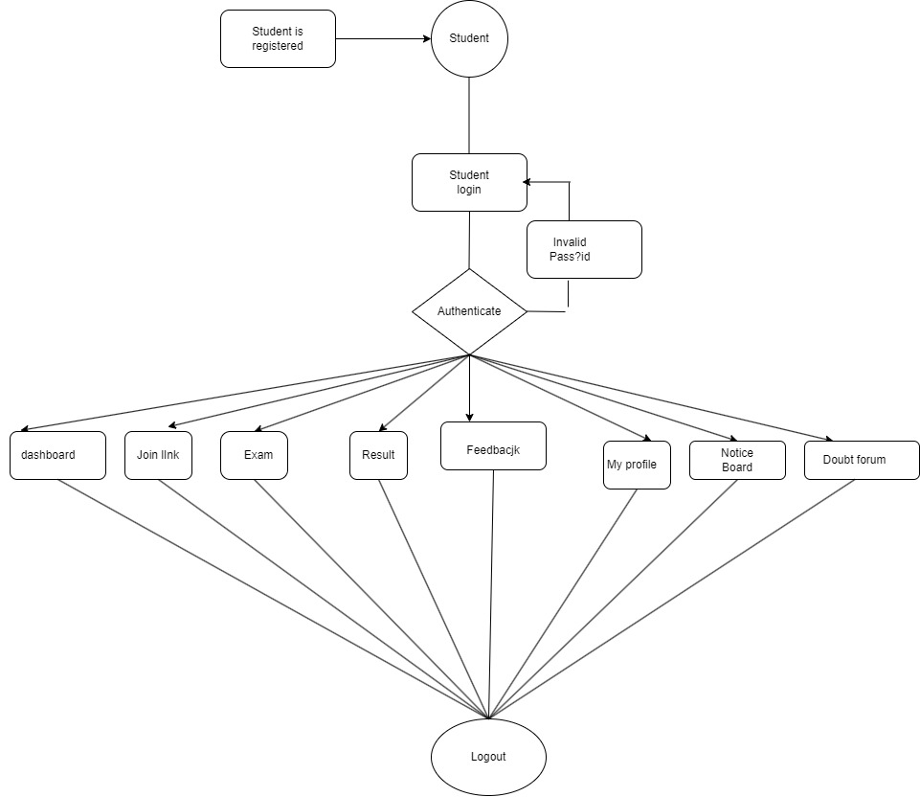

1. FOR ADMINS
   1. Login & Logout – Similar to students, admins can login & logout to access their account.
   2. Generate PRN – For successfully registered students, admin generates PRN which student will carry till the course end as their identities. This PRN is students’ username and default password.
   3. Upload Attendance – Admin will upload students’ attendance.
   4. Set Result – Admin will set result for students which students can access through the portal when they login.
   5. Upload Link – Lecture and Lab Links are uploaded in the given section in the navigation bar.
   6. Upload and Update Notice – Admin will be able to upload and update notice on floating notice board.

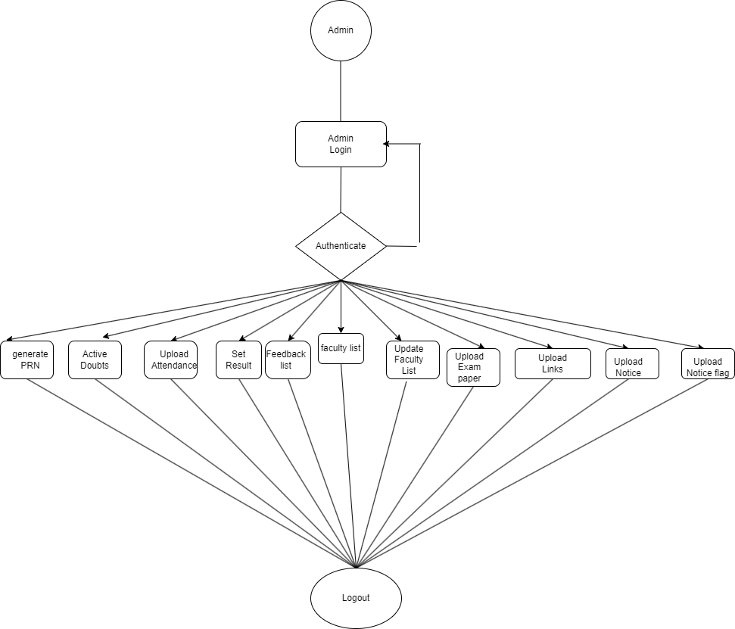

### Figure 2 Admin Activity Diagram

**SEQUENCE DIAGRAM**

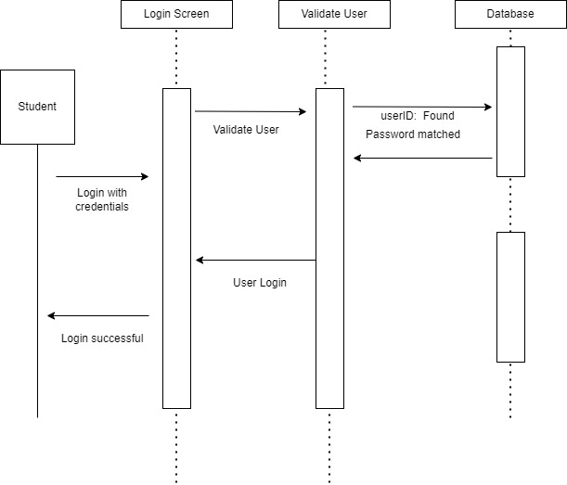

# SYSTEM ANALYSIS

System analysis is the process of gathering and interpreting facts, diagnosing problems, and using the information to recommend improvements on the system. System analysis is a problem-solving activity that requires intensive communication between the system users and system developers.

System analysis or study is an important phase of any system development process. The system is viewed as a whole, the inputs are identified, and the system is subjected to close study to identify the problem areas. The solutions are given as a proposal. The proposal is reviewed on user request and suitable changes are made. This loop ends as soon as the user is satisfied with the proposal.

## EXISTING SYSTEM

The current system for society management is maintain pen and paper data to add new owner of the flat or tenant or workstaff. To circulate the notice secretary has to personally visit the flat owners or write it on the board of the society.

* + - It is less user-friendly.
    - Secretary has to meet each member of the flat and give notice or maintenance bill.
    - It is difficult to gather each member of society at one place.
    - Secretary has to maintain the whole paper work describing the details flats and their owners.
    - It is a time-consuming process
    - Not in reach of distant users.

## PROPOSED SYSTEM

The proposed system provides friendly user interface to every member of the society. The various other functionalities about Cross browsing, various languages suitable for different caste, etc. This application will help all sectors of people which will provide them visibility and smooth functioning. This will be beneficial to all the members who travel abroad and who cannot be a part of each and every notice of the society. This application will travel worldwide and any members will have an access to it. Understanding the needs of the society members and to overcome the manual work of the documentation and make it online which will be feasible and flexible and try to make it user friendly. Web-platform means that the system will be available for access 24/7 except when there is a temporary server issue which is expected to be minimal.

## SYSTEM REQUIREMENT SPECIFICATION

#### GENERAL DESCRIPTION

**Product Description:**

The Society Management System allows members to login with their own account and get updated with society happenings. Society Management System is the website portal to reduce conflicts among society members. The system has automated functionality for calculating monthly maintenance bill and member can view their bill status on their account.

#### Problem Statement:

Major manual efforts in overall modus operandi of the different courses at IACSD, Pune and no

single platform for the students to fulfil their day to day demands for a overall smooth learning experience*.*

#### SYSTEM OBJECTIVES

A web application for every student joining IACSD, Pune as a portal to facilitate all the day to day

Activities and reducing major manual effort of the Course Coordinators by introducing automation at various levels

#### SYSTEM REQUIREMENTS

* + - 1. **NON-FUNCTIONAL REQUIREMENTS**

#### EFFICIENCY REQUIREMENT

When student or admin visits system it should access in an efficient manner.

#### RELIABILITY REQUIREMENT

The system should provide a reliable environment to student and admin. All data should be store on server.

#### USABILITY REQUIREMENT

The Web application is designed for user friendly environment and ease of use.

#### IMPLEMENTATION REQUIREMENT

Implementation of the system using HTML, CSS, Bootstrap, JavaScript, Ajax and JQuery in front end with Spring Boot as back end and it will be used for database connectivity. And the database part is developed by MySQL. Responsive web designing is used for making the website compatible for any type of screen.

#### DELIVERY REQUIREMENT

The whole system is expected to be delivered in four months of time with a weekly Evaluation by the project guide.

* + - 1. **FUNCTIONAL REQUIREMENTS**

Following are the functional requirements fulfilled by our project:

* Students can register themselves if they have appeared for CCAT entrance exam for PG Diploma courses and have valid CCAT number.
* Further, they are asked to fill in their personal details and address details.
* Once all students are registered, they get a confirmation Email from IACSD

for successful registration.

* Admin generates PRNs for successfully registered students.
* Students can login for the first time with username and default password as their own PRN.
* Students now can edit their profile, change password and use all the functionalities effectively.
* Admins can update Notice Board, Schedule, Exam papers, etc.

Admins can get the results and faculty feedbacks from students, too

# SYSTEM DESIGN

System design is the solution for the creation of a new system. This phase focuses on the detailed implementation of the feasible system. Its emphasis on translating design. Specifications to performance specification. System design has two phases of development.

* Logical Design
* Physical Design

During logical design phase the analyst describes inputs (sources), outputs(destinations), databases (data sores) and procedures (data flows) all in a format that meets the user requirements. The analyst also specifies the needs of the user at a level that virtually determines the information flow in and out of the system and the data resources. Here the logical design is done through data flow diagrams and database design. The physical design is followed by physical design or coding. Physical design produces the working system by defining the design specifications, which specify exactly what the candidate system must do. The programmers write the necessary programs that accept input from the user, perform necessary processing on accepted data and produce the required report on a hard copy or display it on the screen.

## INPUT AND OUTPUT DESIGN

#### INPUT DESIGN:

Input design is the link that ties the information system into the world of its users. The input design involves determining the inputs, validating the data, minimizing the data entry and provides a multi-user facility. Inaccurate inputs are the most common cause of errors in data processing. Errors entered by the data entry operators can be controlled by input design. The user-originated inputs are converted to a computer-based format in the input design. Input data are collected and organized into groups of similar data. Once identified, the appropriate input media are selected for processing. All the input data are validated and if any data violates any conditions, the user is warned by a message. If the data satisfies all the conditions, it is transferred to the appropriate tables in the database. In this project the student details are to be entered at the time of registration. A page is designed for this purpose which is user friendly and easy to use. The design is done such that users get appropriate messages when exceptions occur.

#### OUTPUT DESIGN:

Computer output is the most important and direct source of information to the user. Output design

is a very important phase since the output needs to be in an efficient manner. Efficient and intelligible output design improves the system relationship with the user and helps in decision making. Allowing the user to view the sample screen is important because the user is the ultimate judge of the quality of output. The output module of this system is the selected notifications.

# DATABASE DESIGN

* 1. **DATABASE**

Databases are the storehouses of data used in the software systems. The data is stored in tables inside the database. Several tables are created for the manipulation of the data for the system. Two essential settings for a database are

* Primary key - the field that is unique for all the record occurrences
* Foreign key - the field used to set relation between tables Normalization is a technique to avoid redundancy in the tables.

## SYSTEM TOOLS

The various system tools that have been used in developing both the front end and the back end of the project are being discussed in this chapter.

#### FRONT END:

#### BACKEND:

The back end is implemented using spring-boot and spring MVC.

#### MySQL:

MySQL is the world's second most widely used open-source relational database management system (RDBMS). The SQL phrase stands for Structured Query Language.

#### Spring-Boot:

This is used to connect MYSQL and fetch data from database and store the data in database. The Spring Framework is a[n application framework](https://en.wikipedia.org/wiki/Application_framework) and [inversion of control container](https://en.wikipedia.org/wiki/Inversion_of_control) for the [Java](https://en.wikipedia.org/wiki/Java_platform) [platform.](https://en.wikipedia.org/wiki/Java_platform) The framework's core features can be used by any Java application, but there are extensions for building web applications on top of the [Java EE](https://en.wikipedia.org/wiki/Java_EE) (Enterprise Edition) platform. Although the framework does not impose any specific [programming model,](https://en.wikipedia.org/wiki/Programming_model) it has become popular in the Java community as an addition to the [Enterprise JavaBeans](https://en.wikipedia.org/wiki/Enterprise_JavaBeans) (EJB) model. The Spring Framework is Open-source Framework.

# 

# C:\Users\abhay\Desktop\UCL1.jpg

# C:\Users\abhay\Desktop\UCL2.jpg

# E-R Diagram:

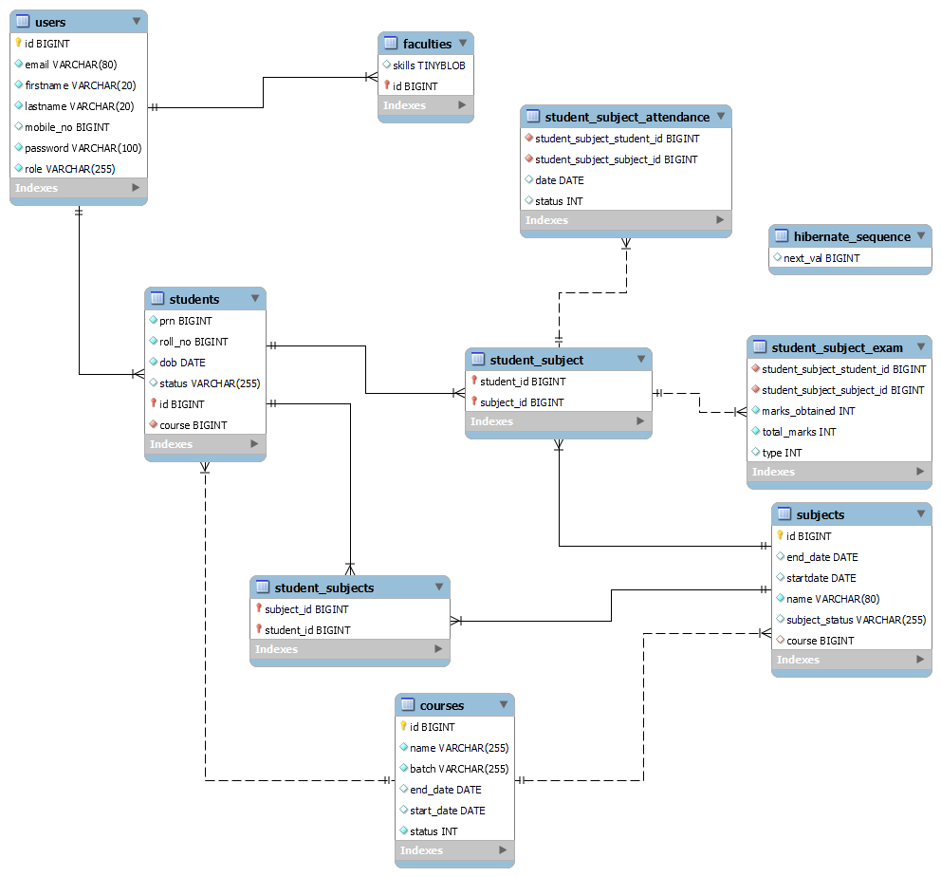

***Figure 8 E-R Diagram***

# TABLE STRUCTURE:

## DATA MODEL

The following tables depict the database design used for “STUDENT PORTAL APP” application:

### Tables for Registration and Login

* + - 1. User Table

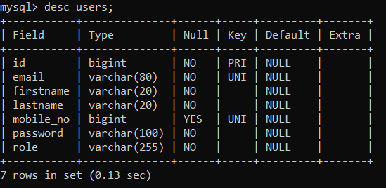

* + - 1. Student And faculty Table

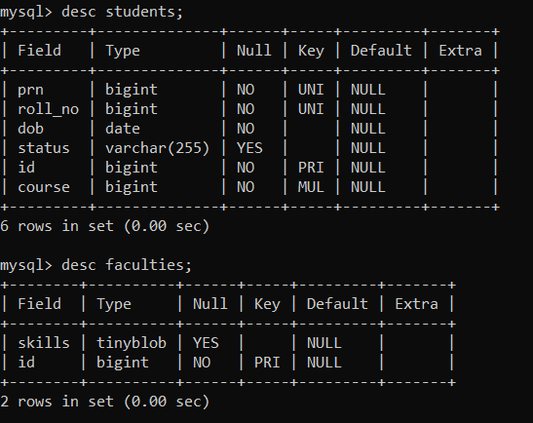

* + - 1. Subject Table

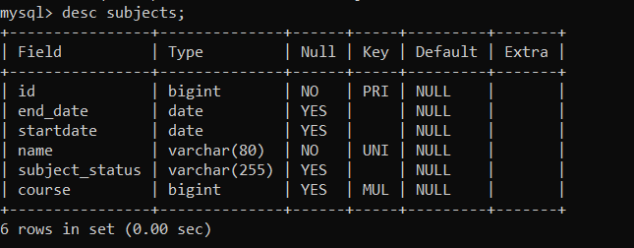

* + - 1. Modules Table and Module 1 Table

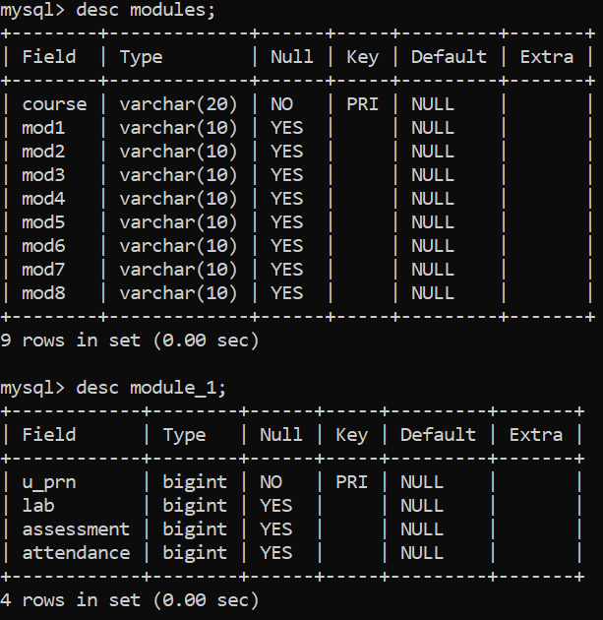

* + - 1. Student and subject link table

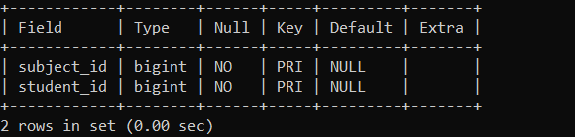

* + - 1. Exam details and attendance table

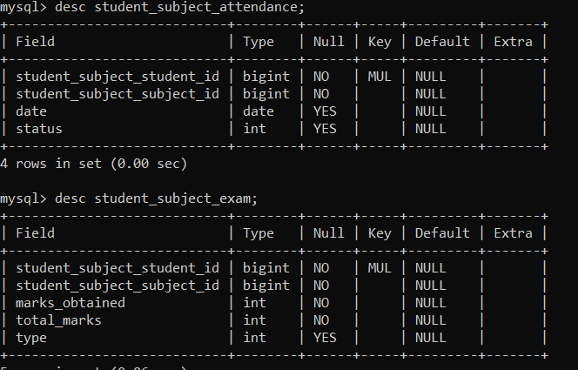

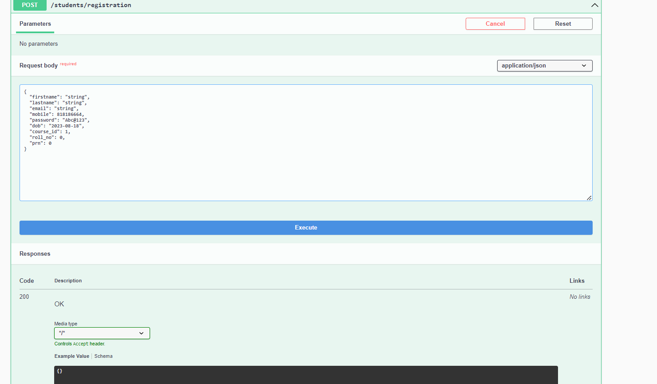

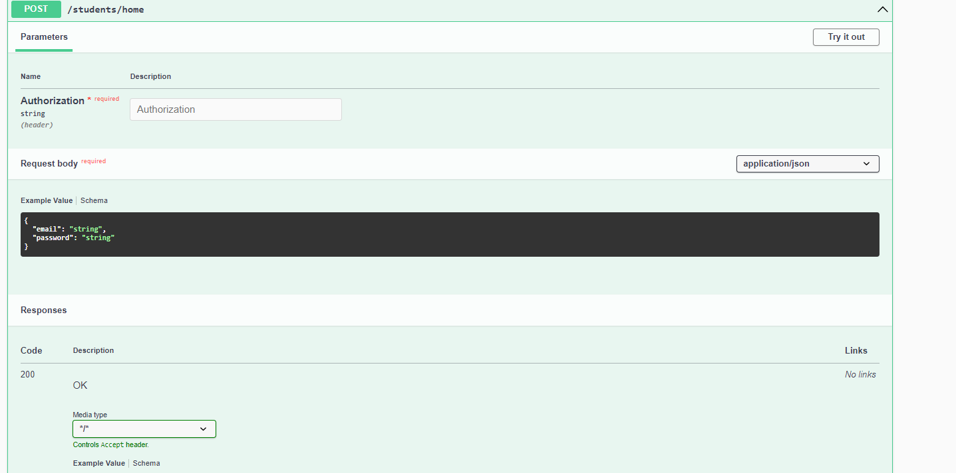

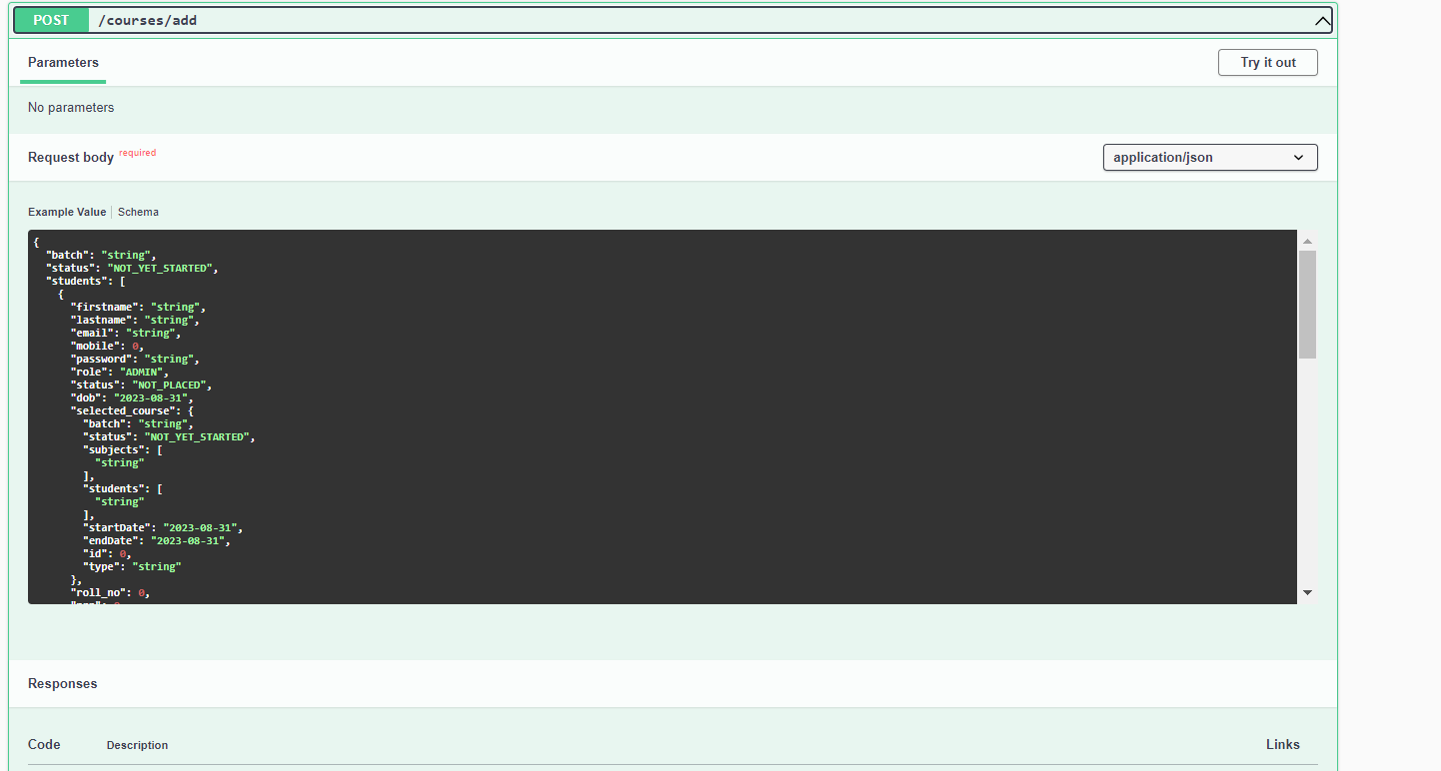

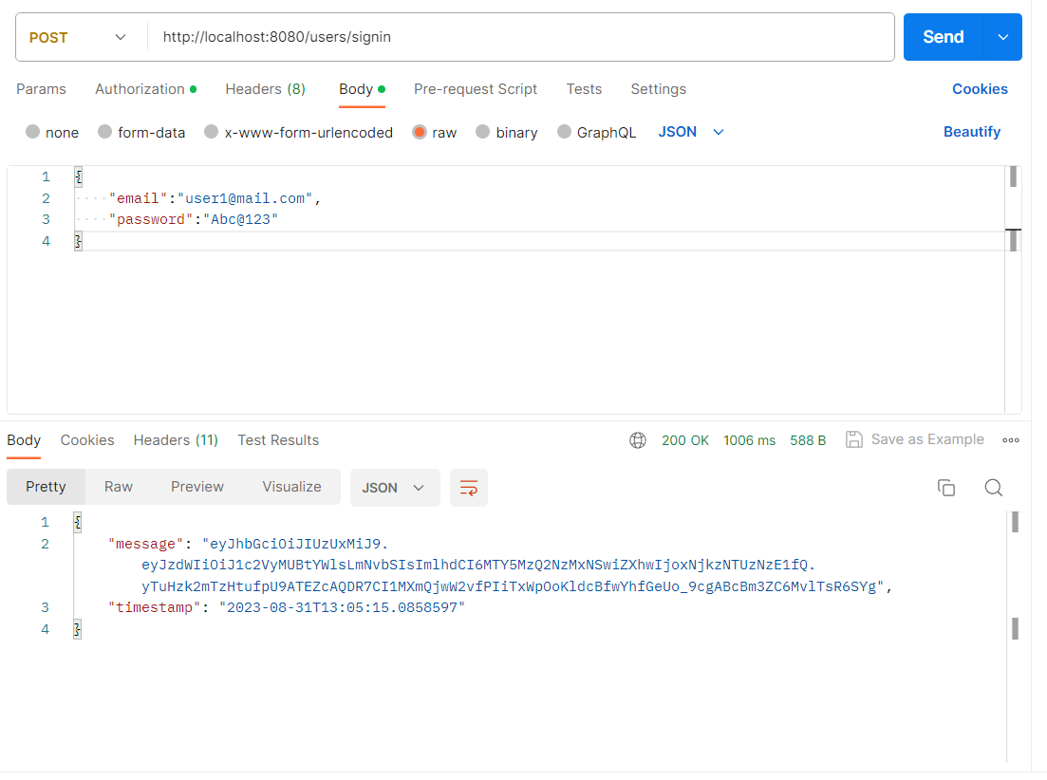

# CONCLUSION

“Classhub”, an online student management portal, was developed by our project team to provide a platform for PG Diploma courses of IACSD Pune students and to simplify the admin’s work. We tried using the latest technologies that are cross-platform and robust. Each and every software we used was open-source in nature, which keeps the cost of production at a minimum.

We were also meticulous about the user experience aspect of our application so that navigating our website is an easy and seamless experience.

In conclusion, “Classhub” as a portal would definitely be beneficial for IACSD Pune for managing their PG Diploma students efficiently. We are confident that the numerous features and visually appealing look of the portal will definitely make this portal effective for all the students and admins. This portal can be scaled on higher side to add more features to it.